**REGGY U. OLEGARIO**

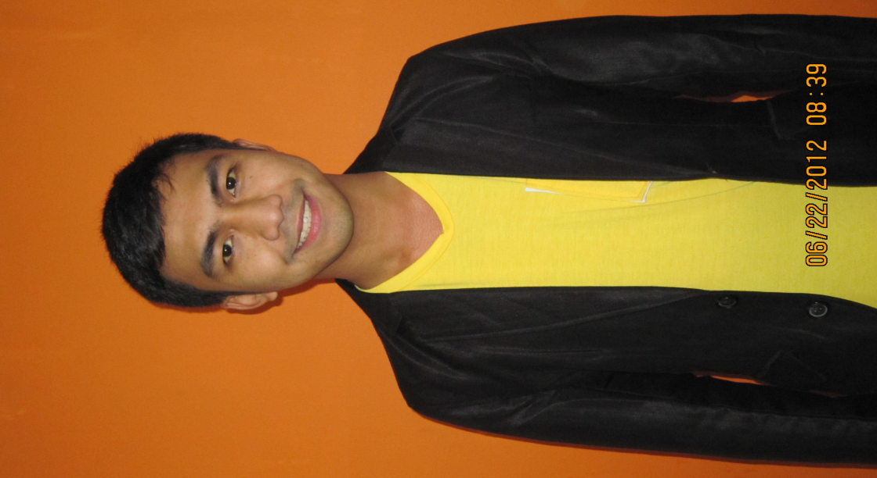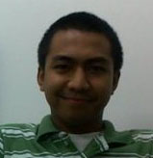

Address: 8-D KG St., West Kamias, Quezon City

Contact Number: 09202359123

Email: reggyolegario@yahoo.com

**GOAL:** A position that will effectively utilize my acquired expertise, creative talents and commitment to excellence. Desire a position with career growth potential.

**EDUCATION:**

**College-Bachelor of Science in Tourism Graduate ABE International Business College May 2006**

**EXPERIENCE/JOB DESCRIPTION:**

**Research Analyst KMC Mag Solutions October 2012-present**

-Do outbound calls to verify leads’ corporate information.

-Look for the correct person in-charge on a specific task, depending on the specifications of the client.

**Inbound Sales Representative StarTek March 2012-August 2012**

-Process order and set installation schedule of services ordered.

-Provide recommendations for the services needed based on the needs of the customer.

-Handle concerns of existing customer with the intention of up selling before transferring to other department.

**Technical Support Representative StarTek July 2011-February 2012**

-Handle technical concerns of customer and patiently walk them through the process of resolving their technical issues

-Provide recommendations and process free equipment orders.

-Educate and handle concerns of existing customer before transferring to other department.

**Quality Assurance Specialist TSD Global Philippines April 2010-June 2011**

-Participates in design of call monitoring formats and quality standards.  
-Performs call monitoring and provides trend data to site management team.  
-Uses quality monitoring data management system to compile and track performance at team and individual level.  
-Participates in customer and client listening programs to identify customer needs and expectations.  
-Provides actionable data to various internal support groups as needed.  
-Provides feedback to call center agents, team leaders and managers.  
-Prepares and analyzes internal and external quality reports for management staff review.

**Outbound Sales Representative TSD Global Philippines July 2009-March 2010**

-Call existing customers/sales leads and deliver a sales presentation from a pre-written script with the goal of up-selling.

**Inbound Sales Representative E-telecare/Stream Global May 2008-June 2009**

-Offers alternative solutions when appropriate with the objective of selling the product to the customer.

-Handles business transactions in connection with activation of new customer accounts.

-Utilizes systems to initiate and complete service orders and handle customer requests.

-Continually maintain working knowledge of all company products, services and promotions.

-Make recommendations according to customer’s needs on features, upgrades and rate plans.

**CHARACTER REFERENCES:**

**Rizza Ladrero Team Leader 0906-501-2340**

Startek

**June Francisco Operations Manager 0917-543-6177**

Affiliated Computer Services (ACS) MOA

**Jayjay Nino Tayag Team Leader II 0932-886-1001**

Teletech, Telstra

_______________________________

**Reggy U. Olegario**